**Social Media Scheduling Mobile Application**

|  |  |  |  |
| --- | --- | --- | --- |
| Md Hasib Zaman  Department of Electrical and Computer Engineering  North South University Dhaka, Bangladesh  hasib.zaman@northsouth.edu | Jahin Mahbub  Department of Electrical and Computer Engineering North South University Dhaka, Bangladesh jahin.mahbub@northsouth.edu | Yeahia Mahammad Arif  Department of Electrical and Computer Engineering North South University Dhaka, Bangladesh yeahia.arif@northsouth.edu | Shaikh Shawon Arefin Shimon  Lecturer  Department of Electrical and Computer Engineering  North South University  Dhaka, Bangladesh  shaikh.shimon@northsouth.edu |

**Abstract**

Social Media involvement in our lives has been increasing daily, and maintaining this social media life has become more complex. Sometimes we might have to post our content remotely even when we are away from our workspace, or we might have to post something at a specific time, but we might be busy at that time. So, these issues bring to our solution the social media scheduler application where people can schedule their social media posts, and they can post from multiple platforms from one hub.

**Keywords**

Social Media; influencer; online business; Schedule Post;

# Introduction

People are controlling their personal and business life both in social media. They have to come up with ideas day by day to upload their content. But often, they forget the content which they thought of. In the past, people used to follow the classical way and write in a notebook. After a while, they thought of jotting it down on a notepad, a software for keeping notes. But in recent times, life has been made easier. Social Media applications have added the feature of scheduling posts. But nowadays, we also have to maintain social media accounts and many more concerned sites to keep our business running smoothly and content to reach out to people effectively.

The Social Media scheduler is an application that appoints or schedules posts/tweets for social media. The application will be a mobile application. It will be running on both IOS and Android.

The purpose of the project is to make people’s day-to-day life more manageable, allow them to use social media remotely, and easy maintenance of their social media accounts from one hub and post when they are roaming.

We have a vast target audience. Everyone who is on social media can be our target. Our particular targets would be those who use their social media to conduct business.

# Background

These days there are a considerable number of social media sites. That’s why target platforms are scattered, but after thorough research, we came up with a few social media sites that we can support through our application if their privacy allows us: Facebook, Twitter, Instagram, Linkedin, Tiktok, Reddit, Snapchat, Quora.

Every social site has its own way, and its posting methods are different. Some of them can add images, and in some, if the image is mandatory.

|  |  |  |  |  |  |  |
| --- | --- | --- | --- | --- | --- | --- |
| Social Media | Post | Image | Video | Caption | Character Limit | Stories |
| Facebook | ✔ | ✔ | ✔ | ✔ | 63,206 | ✔ |
| Twitter | ✔ | ✔ | ✔ | ✔ | 280 | ✖ |
| Instagram | ✔ | ✔ | ✔ | ✔ | 2200 | ✔ |
| Linkedin | ✔ | ✔ | ✔ | ✔ | 1300 | ✔ |
| Tiktok | ✔ | ✖ | ✔ | ✔ | 100 | ✔ |
| Reddit | ✔ | ✔ | ✔ | ✔ | 40,000 | ✖ |
| Snapchat | ✖ | ✔ | ✔ | ✖ | ✖ | ✔ |
| Quora | ✔ | ✔ | ✔ | ✔ | 40,000 | ✖ |

The potential market competitors against our project that we have noticed are SocialPilot, HootSuite, Buffer, Sendible, AgoraPulse, Sprout Social, CoSchedule, Zoho Social, eClicher, MavSocial, MeetEger, SmartQueue, Facebook Business suite, Combin Free Instagram Scheduler.

**Facebook Business Suite-**

Facebook business suite is the official application tool that helps to organize your Facebook page and Instagram page. It has a web version and an ios and android version as well. The feature that it holds are:

* View your business at a glance
* View Activity
* Use Inbox
* Create Posts and Stories
* Access Commerce Manager
* Create Ads
* View Insights
* Access More Tools
* Schedule posts

The business suite has a lovely way of scheduling posts. It would be considered the best in our opinion. It uploads the whole file to a server and posts when it’s scheduled. It also shows the preview of the scheduled post.

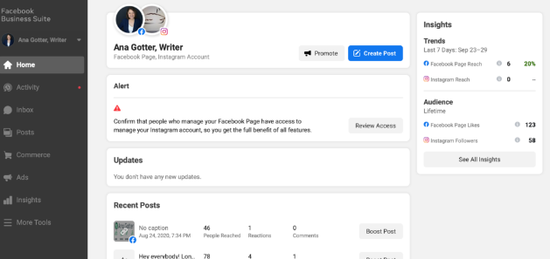

Figure 2.1: Facebook business suite

**Combin Free Instagram Scheduler-**

Combin’s goal is to provide efficient Instagram marketing solutions. It doesn’t have any mobile version. It only offers a desktop version. The application has to be running in the background to post on Instagram. It doesn’t support any other platform and media.

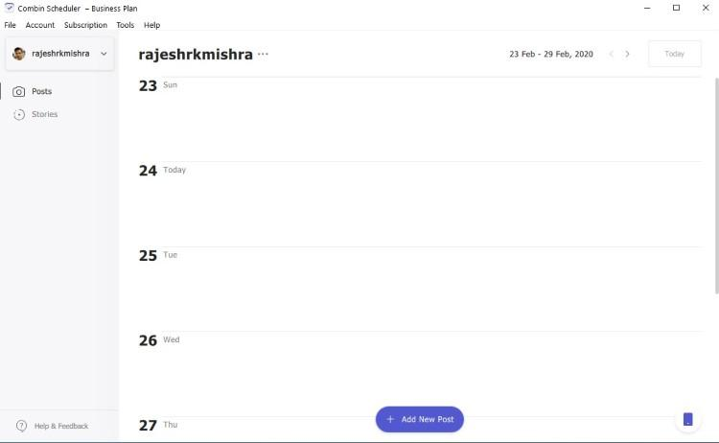

Figure 2.2: Combin-Scheduler

**Buffer-**

Buffer is another social media management tool. It allows you to manage multiple accounts with pricing. Buffer offers using Facebook, Twitter, Instagram, and Linkedin to connect and schedule posts. It uploads everything required to some cloud storage and then posts when it’s necessary to. Buffer has an analytic section as well, which gives the user some insights about the posts.

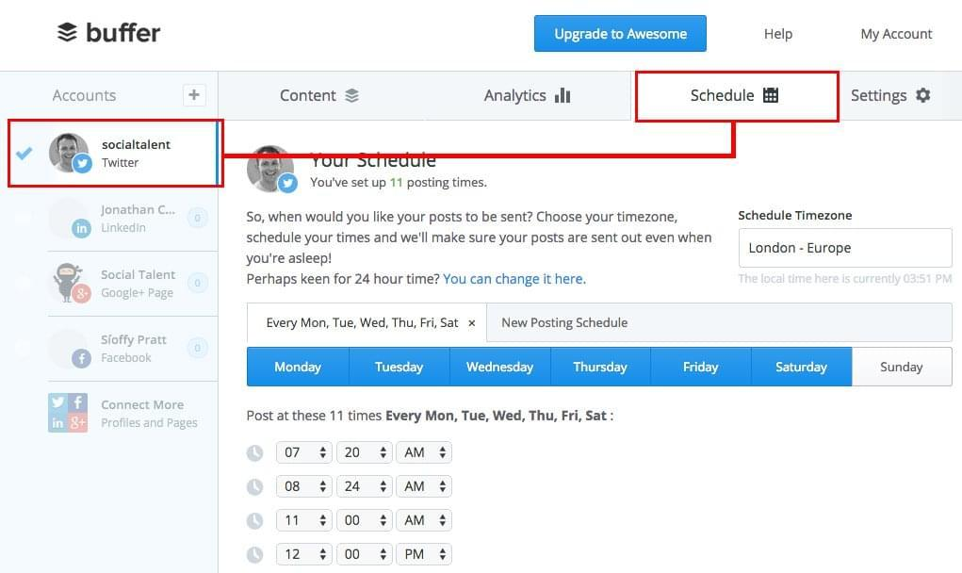

Figure 2.3: Buffer Social Media

**Hootsuite-**

Hootsuite is another useful application for managing social media network channels. Often referred to as a social media management system or tool, it enables you to view multiple streams at once and monitor what customers are saying. You can post updates, read responses, schedule messages, view statistics, and much more. Many international brands—including Coca-Cola and Sony Music—utilize this time-saving approach to social media marketing. With Hootsuite, you can post updates, review responses, and connect with your customer base on over thirty-five popular social networks. Including Twitter, Facebook (includes Profiles, Events, Groups, and Fan Pages), LinkedIn (includes Profiles, Pages, and Groups), Google+, Foursquare, WordPress blogs, and several other platforms via third-party apps.

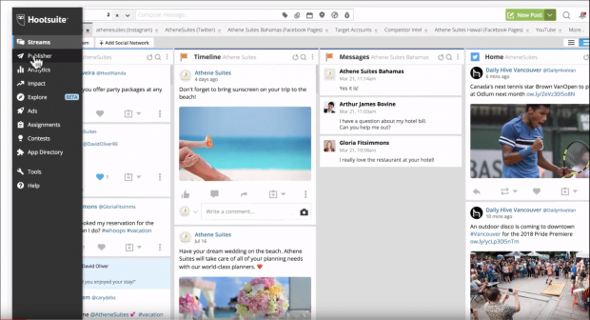

Figure 2.4: Hootsuite

**SocialPilot-**

SocialPilot is a social media scheduling and marketing platform developed specifically for agencies and social media professionals. Used by over 40,000 agencies and social media teams, SocialPilot is designed to help users enhance the efficiency of their online marketing strategies and efforts and save time and money. Moderately priced and appropriately integrated, SocialPilot is meant to be accessible for businesses of all scales and industries. There is a free starter package for three connected profiles you could use to examine the features and confirm SocialPilot is an intelligent choice for your business.

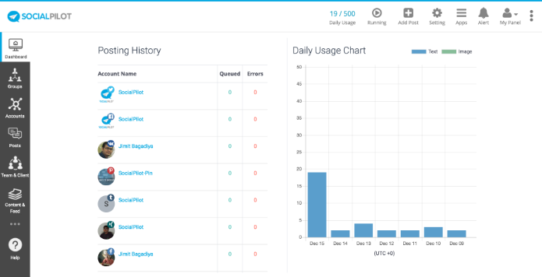

Figure 2.5: SocialPilot

**Sendible-**

The Sendible platform brings all your social networks together into a centralized hub and is the easiest way to execute a winning social media strategy for multiple brands at scale. Positioned as a productivity tool for agencies, you can be confident that your team will save hours!

With robust social media engagement, monitoring, publishing, lead generation, and reporting features, Sendible gives you all the tools to delight your clients every step of the way.

Sendible’s social media automation features help to simplify the process of driving interactions, growing a following, and starting conversations on social media. The unified Priority Inbox is loved by brands and agencies alike, saving hours each day by consolidating the most important conversations from multiple sources into a single stream. With gorgeous, social media reports that are designed to impress, you can deliver both meaningful and impressive-looking insights showcasing your progress on social media.

**eClincher-**

eClincher platform is built for companies looking for an intuitive yet powerful solution to manage their brand reach, reputation, and growth online. Popular features include suggested content & free media assets, live inbox to interact across all channels/message types, post-editing, scheduler & visual calendar, post-boost, monitoring with live feeds, smart queues & auto-posting, analytics & reports, team collaboration & workflows, mobile app.

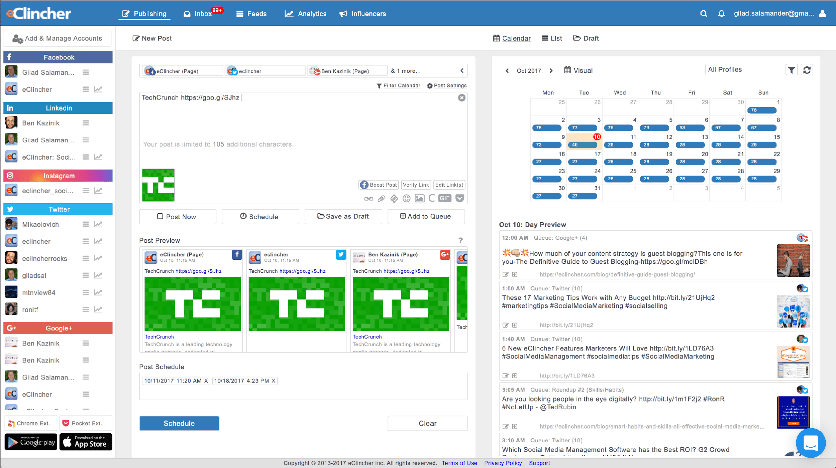

Figure 2.6: eClincher

**Sprout Social**

Sprout Social offers robust social customer service solutions for leading agencies and brands, including Hyatt, Ogilvy, Leo Burnett, Evernote, and Microsoft. Sprout enables brands to simplify social monitoring, listening, customer service, engagement, and much more. Sprout supports Facebook, Twitter, Instagram, LinkedIn, and Google+ & integrates with Bitly, Google Analytics, Zendesk, Feedly & UserVoice.

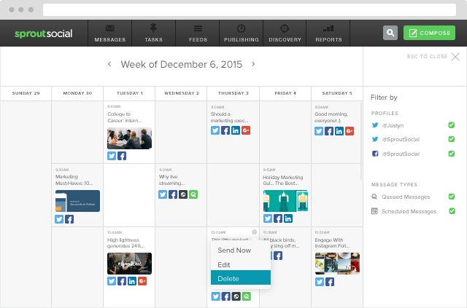

Figure 2.7: Sprout Social

|  |  |  |  |  |  |  |  |  |
| --- | --- | --- | --- | --- | --- | --- | --- | --- |
| Application | Scheduling | Analytics | Moderation | Collaboration | Content Curation | Bulk Scheduling | Cost of 5 user | Free Version |
| SocialPilot | ✔ | ✔ | ✔ | ✔ | ✔ | ✔ | 50/m | ✖ |
| Hootsuite | ✔ | ✔ | ✔ | ✔ | ✔ | ✖ | 599/m | ✔ |
| Buffer | ✔ | ✔ | ✖ | ✔ | ✖ | ✖ | 99/m | ✔ |
| Sendible | ✔ | ✔ | ✔ | ✔ | ✔ | ✔ | 199/m | ✖ |
| AgoraPulse | ✔ | ✔ | ✔ | ✔ | ✖ | ✖ | 199/m | ✖ |
| Sprout Social | ✔ | ✔ | ✔ | ✔ | ✔ | ✔ | 149/m | ✖ |
| CoSchedule | ✔ | ✔ | ✖ | ✔ | ✖ | ✖ | 400/m | ✖ |
| Zoho Social | ✔ | ✔ | ✔ | ✔ | ✖ | ✔ | 200/m | ✖ |
| eClicher | ✔ | ✔ | ✔ | ✔ | ✔ | ✔ | 219/m | ✖ |
| MavSocial | ✔ | ✔ | ✔ | ✔ | ✔ | ✔ | 199/m | ✖ |
| MeetEdgar | ✔ | ✔ | ✖ | ✖ | ✖ | ✔ | 49/m | ✖ |
| SmartQueue | ✔ | ✔ | ✖ | ✖ | ✔ | ✔ | 79.99/m | ✖ |

# Purpose

The purpose of our project is to provide a solution to the people who want to organize, i.e., schedule their social media posts. More importantly, they want to do it through an app that provides them with these services for free. Users have to schedule their posts, and our app will handle posting them on time.

Suppose that McDonald’s’ wants to inform their customers about the availability of their Breakfast special from 7-10 am. But they want to post that at 6 am. They can schedule that post through our app without having someone waking up at 6 am just to post this.

Or perhaps A fashion brand wants to announce as in market their customers to their new spring collection. And also, they want to milk this opportunity by posting each of their designs every alternate day. That is a natural effect that can happen on people, as Kanuri et al. [1] researched. Instead of posting the pictures of all your collections, post each of your new fashion collection pictures one at a time. And that can quickly be scheduled through our app. This is how corporations can directly engage with their customers.

Another real-life example can be celebrity fan accounts on Twitter or Instagram. These provide free publicity and marketing to celebrities without them even knowing about them. Now, if anyone wants to make a new fan account and warm it up and create a following, they have to post daily. And interact with other fans who like the celebrity daily. Our app can be a lifesaver to these users. Just prepare the pictures of, let’s say, Chris Hemsworth, create a schedule on our scheduler. Let’s say the user plans to post three times a day on Instagram, and our app will do the rest. This has also been discussed in an article by Collier [3]. If the users’ followers see the account posting three times a day, that will make the account more engaging; if the account is more engaging and active, Instagram itself will promote the account on their discover page. And the more it is on the discover page; gradually, the following will grow.

# Proposal

Architecture Pattern- Architectural pattern of the proposed application is given below.

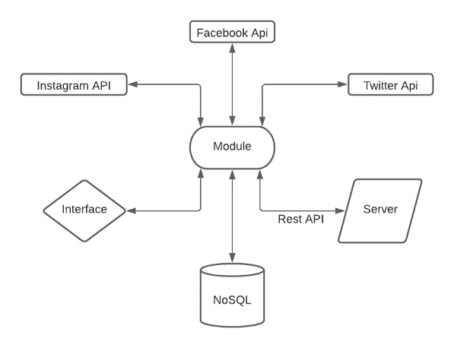

Figure 4.1: Architecture Pattern

We will be using MVVM architecture for our application.

MVVM - MVVM architecture is a Model-View-ViewModel architecture that removes the tight coupling between each component. Most importantly, in this architecture, the children don’t directly reference the parent; they only have the reference by observables.

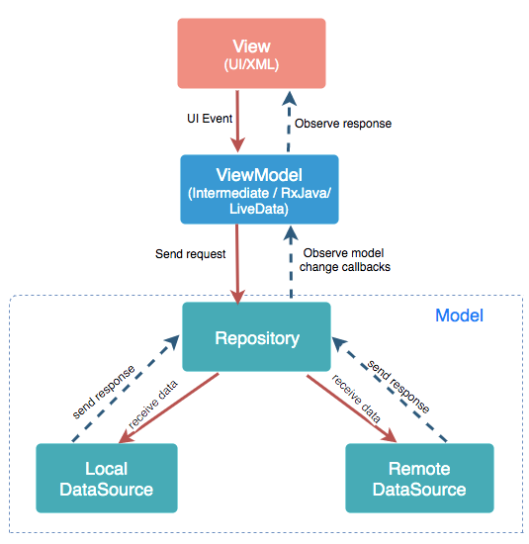

Figure 4.2: MVVM Architecture

Model: It represents the data and the business logic of the Android Application. It consists of the business logic - local and remote data source, model classes, repository.

View: It consists of the UI Code(Activity, Fragment), XML. It sends the user action to the ViewModel but does not get the response back directly. To get the response, it has to subscribe to the observables which ViewModel exposes to it.

ViewModel: It is a bridge between the View and Model(business logic). It does not have any clue which View has to use it as it does not directly reference the View. So basically, the ViewModel should not be aware of the View who is interacting with. It interacts with the Model and exposes the observable that the View can observe

For our Database, we will be using a NoSQL database. Firebase is used in Backend-as-a-Service. It provides developers with various tools and services to help them develop quality apps, grows their user base, and earn profit. It is built on Google’s infrastructure.

Authentication: It supports authentication using passwords, phone numbers, Google, Facebook, Twitter, and more. The Firebase Authentication (SDK) can integrate one or more sign-in methods into an app manually.

Realtime database: Data is synced across all clients in real-time and remains available even when an app goes offline.

Hosting: Firebase Hosting provides fast hosting for a web app; content is cached into content delivery networks worldwide.

Test lab: The application is tested on virtual and physical devices located in Google’s data centers.

Notifications: Notifications can be sent with firebase with no additional coding.

We have also made a user interface design with Figma to explain our idea more appropriately.

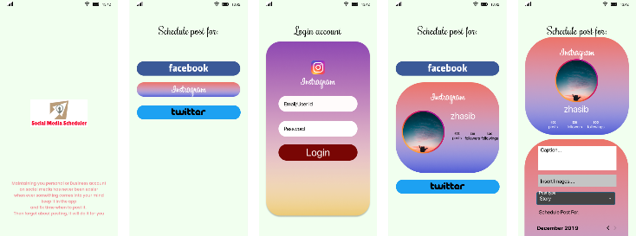

Figure 4.3: User Interface Prototype

# Findings

Researching for this application, we have found out about many metrics and ways of understanding social media that were unknown to us before.

As socially inclined creatures, human beings have embraced technology that connects us with others. Every year, there is an increasing number of people signing up for and using social media. While there weren’t even a billion people using social media back in 2010, the number exceeded more than 2 billion within just five years. In 2019, around 2.77 billion people were using social media. And, with smartphones and internet connectivity becoming cheaper and easier to access, we should expect to see these numbers grow even higher. By 2021, more than 3 billion people will be using social media. This means for marketers that there is enormous potential to reach a massive and engaged audience on social media. And that’s not just limited to the popular social media sites like Facebook, Twitter, and Instagram. [9]

When Pew Research Center began tracking social media adoption in 2005, just 5% of American adults used at least one of these platforms. By 2011 that share had risen to half of all Americans, and today 72% of the public uses some type of social media. [4] Users spend more than 20% of their time online on social media sites. Facebook alone has a worldwide market penetration rate of over 12% of the entire online population; in North America, it is 50%. These rates are snowballing, with Facebook alone gaining 170 million new users between the first quarter of 2011 and the first quarter of 2012, increasing 25%. Facebook mobile use is growing even more quickly, at a 67% annual clip, as of Summer 2013. In 2019, the platform had over 330 million monthly active users. Facebook is currently the largest social media site in the world. With 2.6 billion monthly active users as of 2020, it’s safe to say that nearly every social media user is on Facebook.

On the other hand, Instagram is one of the fastest-growing social networking platforms. While it is primarily app-based, users can also access their feed through the website version. In June 2018, it finally reached 1 billion monthly active users. Instagram is a highly visual platform where users share videos and images. You can also use Instagram Stories and Live features. It is prevalent among the younger generations. According to Statista, 32% of users are aged between 18 and 24, and 33% are aged between 25 and 34.[10] On the other hand, Twitter doesn’t have as many users as other top social media sites; it does have a highly engaged user base. Twitter users send out at least 500 million tweets per day on average.

In an article written by Fan and Gordon [2], they had discussed the growth in use and engagement of social media over the years and how corporations interact with them. It used to be in the mid-2000s corporations would only monitor their customer’s feedback on their respective websites. Over the years, they had figured out that monitoring is not enough. If you want to grow your brand, you have to interact with your customers directly. The brand can later verify that through account analytics.

Now, what we are making, has been done before. Many services like this exist like Hootsuite, Sprout social, Soci, Buffer, and so on. [5] None of them are entirely free, apart from some exceptions like Combin and Crowdfire. And the idea of having a completely free social media scheduler has been done before. Like what Osman et al. did with their app Odoo.[6] Also, the exciting effort to use Twitter as an e-learning tool through a Twitter Scheduler. [7]. That is what we are doing. A free tool to schedule your content across Facebook, Instagram, and Twitter. With plans to expand support to other platforms like Pinterest, LinkedIn, Tiktok, and so on. Initially, we plan to release the app with now financial incentive, but down the line, we have some plans to monetize it through advertisement spaces while keeping to our original promise of keeping the app free. After all, the idea of Fee or Free [8] will cross any app developer’s mind.

# Conclusion

Initially, we plan to execute the social media application for Instagram, Facebook, and Twitter. Afterward, we plan to extend our platform to support various other platforms. Online businesses and individuals need to grow their respective brands through social media platforms and exploit the platforms’ analytics for their gain. At the same time, normal users with no financial incentive need an easy tool to organize their posts. And we can provide that through our android app.

# Acknowledgment

We want to thank and send our gratitude to our supervisor Shaikh Shawon Arefin Shimon, for continuous guidance and encouragement throughout the project. We take this opportunity to express gratitude to all of the Department of electrical and computer science of North South University and all faculty members for their help and support. We also thank our parents for their love and support. Finally, we would like to appreciate the authors’ efforts whose papers and articles helped us throughout our research.

# References

1. Kanuri VK, Chen Y, Sridhar S (Hari). Scheduling Content on Social Media: Theory, Evidence, and Application. Journal of Marketing. 2018;82(6):89-108. doi:10.1177/0022242918805411.
2. Weiguo Fan and Michael D. Gordon. 2014. The power of social media analytics. <i>Commun. ACM</i> 57, 6 (June 2014), 74–81. DOI: https://doi.org/10.1145/2602574
3. Collier, A. 2020. *How to create a social media posting schedule*. Article. Retrieved 6 August 2020 from https://blogs.constantcontact.com/social-media-posting-schedule/
4. “Social Media Fact Sheet”, Pew Research Center, Washington, D.C. (7 April 2021.) https://www.pewresearch.org/internet/fact-sheet/social-media/#how-often-americans-use-social-media-sites
5. Segura, A. 2020. “The Top 15 Tools for Managing Social Media Accounts” Retrieved 22 February 2020 from https://www.searchenginejournal.com/social-media/top-tools/#close
6. Osman, A. A., Adam, A. S. M. and Shire, A. M. O. 2017. POSTING/SENDING MESSAGES ACROSS FACEBOOK, MESSENGER, TWITTER, AND WHATSAPP ALL FROM A SINGLE DASHBOARD. *SUDAN UNIVERSITY OF SCIENCE & TECHNOLOGY.*, Retrieved October 2017 from http://repository.sustech.edu/bitstream/handle/123456789/21309/POSTINGSENDING%20MESSAGES%20ACROSS%20FACEBOOK.pdf?sequence=1&isAllowed=y
7. A. AlSoufi, A. Obead, S. Althawadi, and Z. AlHayki, “Twitter Scheduler System as e-Learning Tool,” 2015 Fifth International Conference on e-Learning (econf), 2015, pp. 161-164, DOI: 10.1109/ECONF.2015.54.
8. Lambrecht, Anja & Misra, Kanishka. (2016). Fee or Free: When Should Firms Charge for Online Content?. Management Science. 63. 10.1287/mnsc.2015.2383.
9. Influencermarketinghub.com, “103+ Social Media Sites You Need to Know in 2021,” 2021. [Online]. Available: https://influencermarketinghub.com/social-media-sites/ [Accessed: 22-May-2021].
10. Statista.com, “Distribution of Instagram users worldwide as of January 2021, by age group” 2021. [Online]. Available: https://www.statista.com/statistics/325587/instagram-global-age-group/ [Accessed: 22-May-2021].